A SHORT BIOGRAPHY OF GEOFFREY F. SALANJE

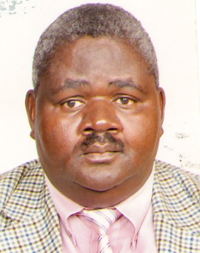

STUDIES: Bachelor’s degree in Social Science (majoring in Sociology, Statistics and Management) – University of Malawi (1985); Post-Graduate diploma in Library Studies – University of Botswana (1988) and a Masters degree in Library Studies – University of Wales, UK (1991).

AREAS OF EXPERTISE: Knowledge Management, Library management

WHY AND WHEN I CHOSE LIBRARIANSHIP AS MY CAREER. I fell in love with the profession in 1984 when I did a three months long vacation attachment in an academic library. That time I was in the third year of my four years bachelor’s degree programme. I was first introduced to the profession for the first time. After finishing my bachelor’s degree in Social Science, I then joined the profession in March, 1986. I am about in about a year’s time upon reaching 60years of age!

AN EXPERIENCE RELATED TO MY PROFESSION: It has been a very interesting 34 years journey. Over the years I have grown academically and professionally. Academically I have attained a post-graduate diploma and master’s degree in library studies having entered the profession with a social science bachelor’s degree. Professionally I have raised through the ranks from a mere an Assistant Librarian Trainee under university of Malawi to a University Librarian for Lilongwe of Agriculture and Natural Resources (LUANAR). I have worked almost in all departments/section within an academic library like Acquisitions, Cataloguing, Special Collections, Library Automation, and Library management. A particular experience I cherish most in my profession is when I attained a position of a University Librarian in June 2013. I feel I have reached a pinnacle in my profession and am very satisfied.

COUNTRIES VISITED. In my career I have travelled to countries such as Ethiopia, Netherlands, Germany, Armenia, Ghana, Namibia, Sweden, Tanzania, Kyrgyzstan, United Kingdom, Swaziland, Italy, Georgia, South Africa, France, Rwanda, Latvia, Turkey, USA, Uganda, Moldova, Botswana, Qatar, Kenya, Norway, Zambia and Thailand for educational visit and attending / presenting papers at workshops or conferences.

