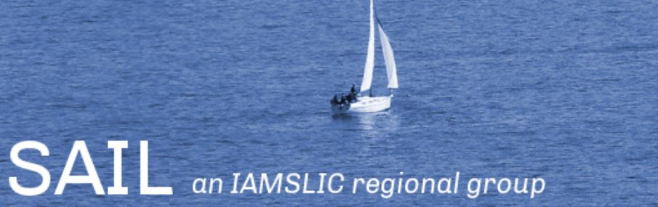
SAIL 2017 – Great Lakes, Great Libraries, UW-Madison

Please submit to Alisun DeKock at adekock@sheddaquarium.org by Feb 28, 2017.
Name:

Title:

Institution:

Address:

Country: USA

Phone Number:

Fax:

Email:

Title of Presentation:

Author(s):

Type of presentation:
- Presentation [length? Circle one: 30, 45 or 60 minutes]
- Panel discussion
- Poster
- Flash presentation (1 to 3 minute presentations)

Indicate AV/Computer equipment needed:
- Computer Graphic Display (i.e. presentation software)
- Internet access
- Other (specify)

Abstract:

