## 2 logo afriamslic sans écriture-2.10.2019.png ****African Association of Aquatic and Marine Science****

## ****Libraries and Information Centers****

## 

## ****Annual Report of AFRIAMSLIC-2019****

## ****MEMBERSHIPS STATUS****

## There are 31 members from 20 countries in Africa:

## New Members (6):

## 4 sponsored by IAMSLIC for 3-year 2019-2021(1from Cameroon, 3 from Uganda)

## 1 from Cameroon

## 1 from Uganda (sponsored by Ian Stewart for 3-year 2019-2021).

## Renewed Memberships (20):

## 13 sponsored by IODE/IOC for 2 years: 2018-2019

## 7 sponsored by ASFA/FAO for the 3-year period 2019-2021

## Potential Members: a preliminary list of potential members from different countries in Africa was developed and special efforts were made to recruit new members from Egypt and Sudan (ASFA will fund).

**ACTIVITIES**

2019 was a quite busy and challenging year for AFRIAMSLIC.

* **Restructuring of AFRIAMSLIC:**

An effort to restructure AFRIAMSLIC was a priority in order to involve in its activities the maximum members, to strengthen communication among them, to provide new opportunities for creating equitable and more lasting outcomes.

In order to involve its members in activities maximally, AFRIAMSLIC carried out restructuring to strengthen communication and providing new opportunities for creating equitable and more lasting outcomes.

The creating of Executive Board, Committees and Sub-Committees was very vital for the good functioning of the regional association. Much of AFRIAMSLIC’s work was done on a volunteer basis by the members of board and committees. Boards and committees carry out a variety of tasks.

* **Afriamslic Executive Board:** It was important to create a team involving committees’ representatives who were willing to carry out projects and activities. The Board organizes monthly virtual meetings through Skype on the 1st Tuesday of the being of each month. These meetings are an opportunity to follow up progress made in the activities, to move ongoing projects forward in order to achieve visible and concrete results in a short time. The AFRIAMSLIC Executive Board is comprised actually of eight members:

1. **Saida Messaoudi**, Chair
2. **Alice Endra**, Secretary
3. **Arame Keita**, Past Chair
4. **Geoffrey Salanje**, Handbook &Bylaws Committee Leader
5. **Maymouna Kane**, Marketing & Communication Committee Leader
6. **Raphael Okeyo**, Directory Committee Leader
7. **Mercy Stephen Sebuliba**, Membership Handbook Committee Leader
8. **AssaneDeda Fall**, Finance Committee Leader

* **Committees, Sub-Committees, Leaders and Sub-Regional Representatives:** Five committees were set upon April 2019. Inside Committees, there are leaders, sub-committees, sub-regional representatives and staff.
* **Membership Committee** (Mercy Stephen Sebuliba, Leader): This committee shall be responsible for increasing members of AFRIAMSLIC by attracting new members and encouraging renewal of memberships (of all librarians, active and retired; library graduate students, friends…), updating the list of members, plan activities for members to be involved in.
* **Sub-Regional Committees and Representatives**: Acting within a decentralized approach, AFRIAMSLIC created in September 2019, 5 sub-committees under Membership Committee and designate Regional Representatives. They shall be responsible for recruiting new members from their sub-regions, identifying other potential member organizations and updating the list of members in their sub regions of Africa:
* **North Africa Representative**: Bouchra Bazi (Morocco)
* **South Africa Representative**: Linea Lipinge (Namibia)
* **West Africa Representative**: Coffi Ferdinando Rock GBEDO (Benin)
* **East Africa Representative**: Raphael Okeyo (Kenya)
* **Central Africa Representative**: Jean Marie Bope (Congo)
* **Marketing & Communication Committee** (Maymouna Kane, Leader): This committee shall be responsible for managing marketing and branding of AFRIAMSLIC, Disseminating the organization information to stakeholders through use of the website, leaflets, flyers, brochures, newsletters and manage social media platforms;
* **Handbook & Bylaws Committee** (Geoffrey Salanje, Leader): This Committee was created to collect all available information about AFRIAMSLIC Association's history, benefits, organization...etc to be put in one book. The primary responsibility of the Handbook and Bylaws Committee is to keep the AFRIAMSLIC Handbook and bylaws updated on a continual basis and a new version is made accessible via the AFRIAMSLIC website. Older versions should be retained for historical purposes.
* **Finance Committee** (Assane Fall, Leader): It shall be responsible for sourcing resources and financial support (as sponsors and partners) to fundraising the association activities and help members to attend meetings and conferences ;
* **Directory Committee** (Raphael Okeyo, Leader): It will be responsible for coordinating with regional and national representatives to collect information to develop and update a database of the **AFRIAMSLIC directory** “Directory of African Aquatic and Marine Sciences Libraries and Information Centers”. Centers involved with aquatic science: Marine, Brackish & Freshwater science ;
* **Marketing, Communication & Promotion of AFRIAMSLIC :**



* **Giving a brand name to AFRIAMSLIC: the regional group** of Africa shall have a brand name**.** In June 2019 the executive board has officially approved to maintain the acronym “AFRIAMSLIC” and to name as the **“African Association of Aquatic and Marine Science Libraries and Information Centers”.**
* **Developing a logo for AFRIAMSLIC:** a new logo was developed and officially used in the website and in official letters since June 2019.
* **Updating AFRIAMSLIC website**: [www.iamslic.org/afriamslic](http://www.iamslic.org/afriamslic) the AFRIAMSLIC website was developed with the help of Steve Watkins and Arame Keita. Actually, Richard Awah and Aggrey Isabirye are in charge of updating the website. We thank Steve for his efforts, IAMSLIC for hosting the present website and team for its perseverance.
* **Discussion-lists:** AFRIAMSLIC has now two mailing-lists: **1.** for all AFRIAMSLIC members:  [﻿afriamslic@lists.iamslic.org](mailto:afriamslic@lists.iamslic.org) **2.** AFRIAMSLIC Executive Board: [afriamslic-exec@lists.iamslic.org](mailto:afriamslic-exec@lists.iamslic.org) We can reach every member now at a single click.
* **AFRIAMSLIC** **Handbook**: a draft version of an AFRIAMSLIC Handbook was created to give more information about the regional association and to assist those on the AFRIAMSLIC Executive Board and Committees with managing the organization. The last version will be accessible via the AFRIAMSLIC website.
* **AFRIAMSLIC Meetings and IAMSLIC conference:**
* 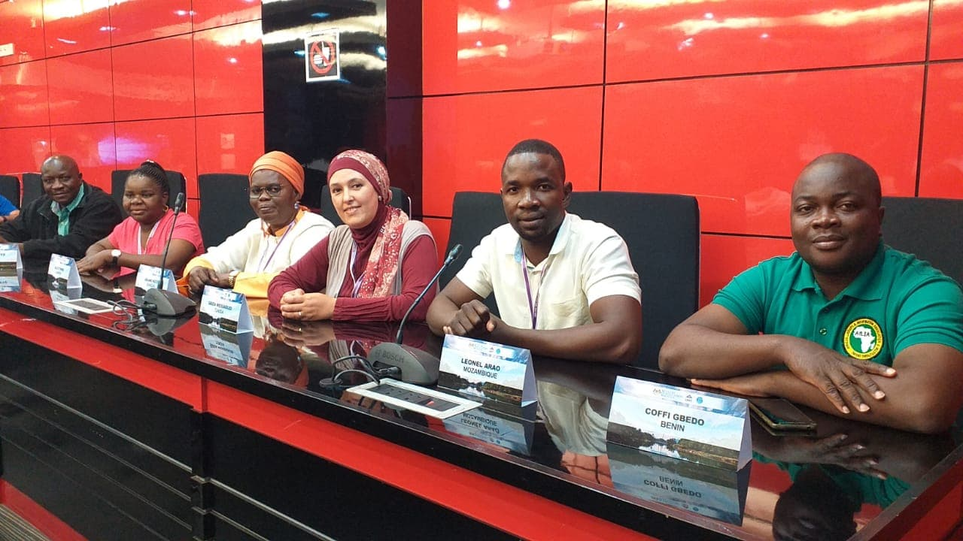**AFRIAMSLIC Meetings:** There was no regional conference for this year because of funding. However, in addition to **monthly meetings (Skype)** of the AFRIAMSLIC Board, the regional group had a **mini-meeting** on 26 September 2019 with 6 AFRIAMSLIC members when attending ASFA Advisory Board Meeting in Terengganu, Malaysia. Minutes of meetings are available in the website.
* **IAMSLIC Conference:** AFRIAMSLIC has two members attending the upcoming IAMSLIC conference in Texas, USA, 20-25 October 2019 [Leonel Arao (Mozambique) and Eva Mutongole Wamala (Uganda)]. I mention that there was a travel grant application funded partially by IAMSLIC for 1 AFRIAMSLIC member. We thank IAMSLIC for its support. In order to help raising funds, Afriamslic has some African items for for the Guin Auction.

|  |  |
| --- | --- |
|  |  |

* **AFRIAMSLIC Activities under other programmes and specialized Information Systems:**

AFRIAMSLIC members are also active actors involved in several programmes and specialized Information Systems, such as: IOC, IODE, ASFA OceanDocs and Aquatic Commons…

* **ASFA Advisory Board Meeting & Joint ASFA-UMT Conference:** 6 AFRIAMSLIC / ASFA partners attended the Board meeting in 22-26 September 2019, Terengganu, Malaysia and participated in the joint ASFA-UMT conference which was an integral part of the ASFA Advisory Board Meeting.

- An AFRIAMSLIC group presentation entitled: "**The Valorization of Grey Literature in Aquatic and Marine Libraries in Africa by its Submission and Discovery via New Technologies: Aquatic Commons, OceanDocs and ASFA**" was presented by Saida Messaoudi, Alice Endra and Raphael Okeyo.

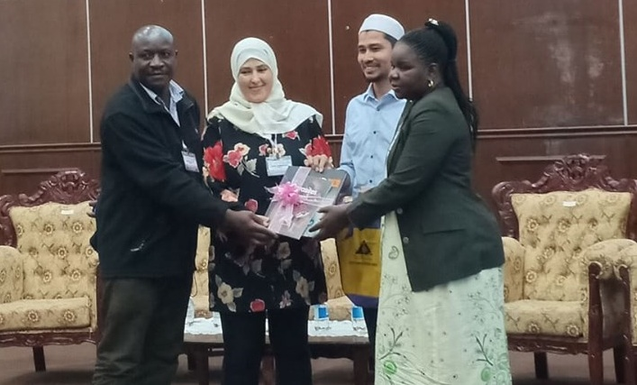

- Article contribution on Grey Literature written by Veronica Sado (NIFFR-Nigeria) was published in the second issue of the **ASFA Newsletter** [www.fao.org/3/ca4630en/ca4630en.pdf](http://www.fao.org/3/ca4630en/ca4630en.pdf)

* **IOC Assembly:** 2 AFRIAMSLIC members (Ms Arame Keita and Mr. Jean Marie Bope) attended the 30th Session of the IOC Assembly in Paris, France. The IOC's member states reviewed progress of all programmes and also consider the proposed work plans for the next biennium.
* **Participation in IAMSLIC Committees:**
* AFRIAMSLIC's Representative and member of the IAMSLIC Executive Board: Saida Messaoudi (2018-2020, 1st term)
* IAMSLIC Membership/Nominating Committee: Arame Keita (2018-2020, 1st term)
* **Financial Plan for AFRIAMSLIC:**
* The AFRIAMSLIC remaining funds (US$700). In fact, last year's funds were completely expended for grants to support travel for participants from the region attending the 44th IAMSLIC Conference, in conjunction with the AFRIAMSLIC Regional Conference, Entebbe, Uganda.
* AFRIAMSLIC received in September a donation of money from **Mr. Ian Pettman (UK).** We thank Ian for his generosity and help to the African Association.

**PROJECT S and UNFINISHED BUSINESS**

* **AFRIAMSLIC Directory Project:** AFRIAMSLIC is in the process of carrying out a survey with the aim of coming up with a **Directory of Africa Aquatic Institutions, Libraries and Professionals: Involved with aquatic science (Marine, Brackish & Freshwater science).**

AFRIAMSLIC requested from IOC expertise help and technical support towards achieving this project. We already get positive reply from Mr. Mika Odido (IOC Coordinator in Africa).

The directory will provide us an effective way to know who else is out in the association to be a new potential member. For further information about this project please visit our website at: [www.iamslic.org/afriamslic/projects](http://www.iamslic.org/afriamslic/projects)

* **AFRIAMSLIC Bylaws:** Last year Arame and Geoffrey worked on updating a working document of Bylaws but I’m afraid that I did not have time to complete the task. I expect more changes will be required before approval.

**THANKS AND ACKNOWLEDGEMENTS**

I would like to thank all active AFRIAMSLIC members for their participation in new initiatives throughout the year. I am very grateful to the AFRIAMSLIC Executive Board members and all the Committees staff for their support, cooperation and hard work.

My thanks go also to **Ian Pettman** for his generous gift to AFRIAMSLIC and to **Ian Stewart** for his support to the association. We are extremely grateful.

**Saida MESSAOUDI**

**AFRIAMSLIC Chair 2018-2020**